导师简介
姓名 | 陈贝 | 性别 | 男 | 出生年月 | 1989.11 | 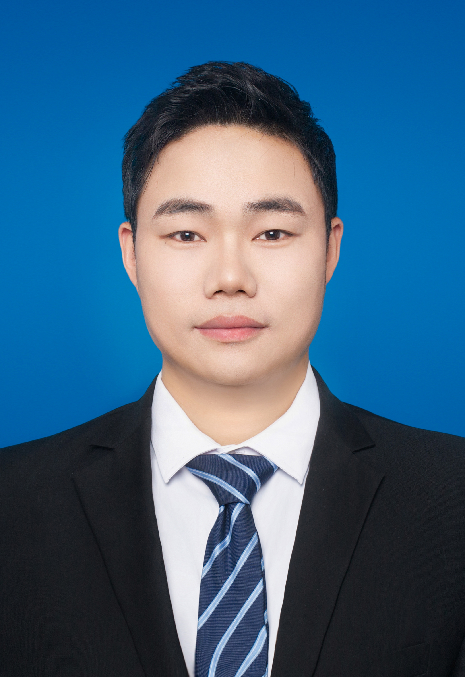
职称 | 直聘副研究员 | 民族 | 汉 | 籍 贯 | 河南驻马店
电子邮箱 | chenb@zzu.edu.cn |  |  | 最终学位 | 博士
研究方向 | - 路面结构与材料  - 路面施工与养护智能管控  - 固废材料绿色再生新技术
主要学习、科研和工作经历 | 2024.07至今 郑州大学 水利与交通学院 直聘副研究员  2018.09-2024.03 河海大学 土木与交通学院 博士  2011.09-2015.06 河南理工大学 材料学院 学士
代表性  科研成果 | 一、科研项目  1.河南省科技攻关项目：北斗高精度定位下沥青路面智能施工云图优化及协同管控技术研究，主持；  2.江苏省教育厅和中央高校业务经费项目：残留水对泡沫温拌沥青混合料界面粘附性影响机理研究，主持；  3.江苏交控高速公路养护科研项目：高速公路沥青路面固废精细化处理与资源化高效利用成套技术研究，子课题二主要完成人；  4.江苏交通控股科技攻关项目：高养公司道路工程处养护基地智能化改造提升项目，主要完成人；  5.浙江省公路管理局科研计划项目：沥青路面智能化施工监控系统技术应用研究，主要完成人；  6.科技部国家重点研发计划：道面设施寿命增强与性能提升技术，主要参与；  7.国家自然科学基金面上项目：钢桥面铺装用树脂沥青高性能化研究，主要参与。  二、论文论著  [1] Bei Chen, Riran Wang, Xin Yu, Fuqiang Dong, Gongying Ding. Identifying the influence of asphalt mixture workability improvement on the characteristics of asphalt, aggregate and void after compaction utilising CT scanning technology. Construction and Building Materials,2024,448.138172.  [2] Bei Chen, Xin Yu, Yingchun Cai, Fuqiang Dong, Jiandong Huang.Research on the migration law of aggregate particles in the compaction process of asphalt mixture based on discrete element method. Construction and Building Materials, 2024,445.137895.  [3] Chen Bei, Yu Xin, Dong Fuqiang, Zheng Changjiang, Zhao Shuang, Zu Yuanzhe. The application of intelligent control technology for the evaluation of temperature segregation in asphalt mixture paving. Construction and Building Materials, 2023, 366,130178.  [4] Chen Bei, Fuqiang Dong, Xin Yu, Changjiang Zheng, Yongjia Guo, Yuanzhe Zu. Research on evaluation method of asphalt mixture workability based on minimum mixing energy consumption.Construction and Building Materials, 2023,389,131760.  [5] Chen Bei, Xin Yu, Fuqiang Dong, Yuanzhe Zu, Jiandong Huang. Influence of asphalt mixture workability on the distribution uniformity of asphalt, aggregate particles and asphalt film during mixing process.Construction and Building Materials, 2023,377,131128.  [6] Chen Bei, Dong Fuqiang, Yu Xin,Zheng Changjiang, Ding Gongying, Wu Wei. Compaction Quality Evaluation of Asphalt Pavement Based on Intelligent Compaction Technology. Journal of Construction Engineering and Management, 2021,147(9).  [7] Chen Bei, Dong Fuqiang, Yu Xin, Zheng Changjiang. Evaluation of Properties and Micro-Characteristics of Waste Polyurethane/Styrene-Butadiene-Styrene Composite Modified Asphalt. Polymers, 2021, 13(14) : 2249-2249.  [8] Chen Bei, Dong Fuqiang, Yu Xin, Ren Shisong, Zheng Changjiang. Chemo-Rheological Characterization of Aging Behaviors of Warm-Mix High-Viscosity Modified Asphalt. Journal of Materials in Civil Engineering, 2022, 34(12).  [9] Chen Bei, Xin Yu, Fuqiang Dong, Wenxiu Wu, Yuanzhe Zu, Shisong Ren. Rheological properties of high viscosity modified asphalt containing warm-mix additives. Journal of Materials in Civil Engineering, 2022.  [10] Fuqiang Dong, Yuanzhe Zu,Chen Bei*, Xin Yu, Jiandong Huang. Laboratory investigations of the effects of asphalt mortar and its viscoelasticity on the workability of asphalt mixtures. Construction and Building Materials, 2023, 389,131756.  [11] Peixing Yang, Fuqiang Dong*, Xin Yu , Yongjia Guo, Yong Jin , Chen Bei*, Yang Jiang , Kaixin Liu.Molecular study on diffusion behavior and performance recovery of aged asphalt binder containing functional rejuvenators.Construction and Building Materials, 2023,407,133536.  [12] Xin Yu, Chen Bei, Fuqiang Dong, Yuanzhe Zu, Shiyu Wang, Jinjin Si, Jiandong Huang. Repurposing waste polyurethane (WPU) into cleaner asphalt pavement materials: A laboratory investigation.Journal of Materials in Civil Engineering, 2023.  三、授权专利  [1]董夫强,陈贝,于新,李宁,祖元哲,王红祥,李靖.一种用于沥青混合料和易性评价模型及和易性评价方法[P]. CN116756823A，2023.6.20.  [2]董夫强,李靖,陈贝,王红祥,于新等.一种基于集料分布均匀性的再生技术用沥青混合料和易性评价方法[P]. CN116296983A，2023.06.23.  [3]孟令国,于新,晏应,陈贝,王坤,李宁,刘林林,祖元哲,一种基于沥青膜裹附均匀性的沥青混合料和易性评价方法[P]. CN116297606A，2023.06.23.  [4]于新,邹小勇,李伟,陈贝,王俊彦.一种基于图像识别的沥青拌合楼生产质量管理系统及方法[P]. CN110297474A，2019.10.01.

